Lab task – Lab 5 – 24k0880

Task 1:
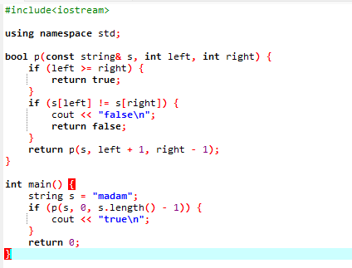
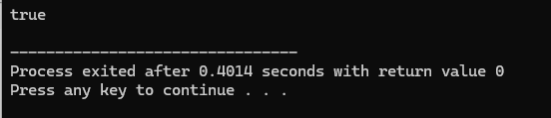

Task 2:
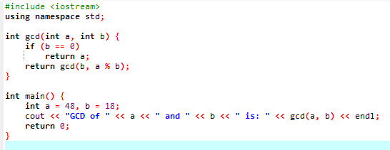
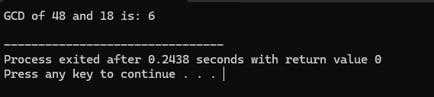

Task 3:
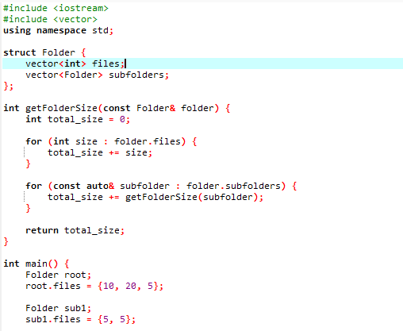
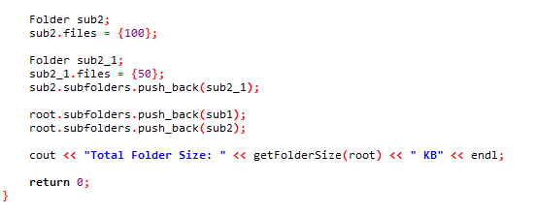
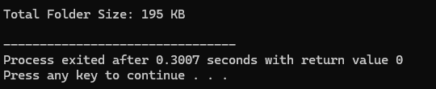

Explaination:
we got a folder system. inside a folder there can be:
- some files (each file has a size in KB)
- some subfolders (and those subfolders can also have files + more folders inside them)
the size of a folder = sum of:
- all the files inside that folder
- plus the size of each subfolder (and each subfolder’s size is also calculated the same way)
so to solve this, we use recursion. recursion just means:
a function calls itself again n again until the problem is fully solved.
We use vectors inside a struct to create a folder, subfolder and file system. Then we traverse each struct and sum all the files and then next sub folder unless an empty sub folder is reached.
here its like:
- start with the current folder.
- add all file sizes inside it.
- then for every subfolder → go inside it (call the same function again) and add its size.
- keep doing this until u reach a folder that has no subfolder left.
- finally we get the total size.

